FAMILIAR AND UNFAMILIAR DESIGN

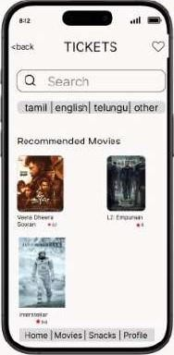familiar design:

Navigation Bar on the bottom to navigate between the most used sections of the app. Used to display the most popular movies as well.

Label displaying the heading of the current page. eg: TICKETS

Search bar to search for the products wishlist icon to

jump to liked and favorite items back buttons is used go back to the previous screen



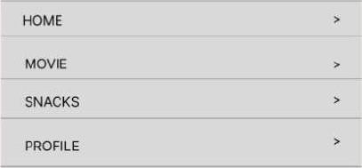Q Search Unfamiliar design:

Interactive hotspots like menu opens a seperate overlay for more accessibility to product search

infinite scroll integrated until end of product